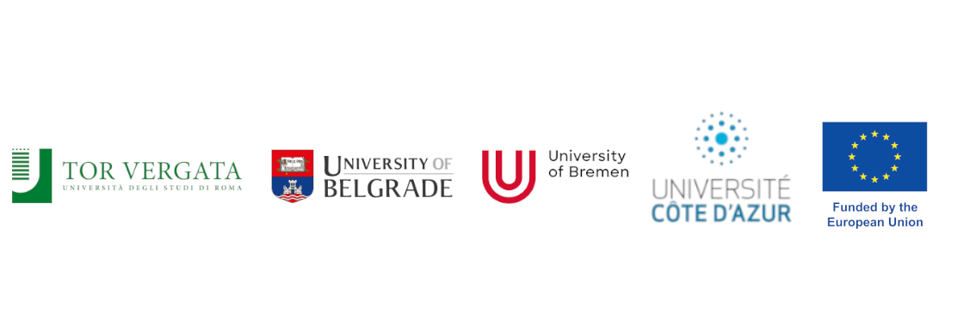

To the MASS Project Office

Physics Department

Tor Vergata University of Rome

Via della Ricerca Scientifica, 1

00133 Roma – ITALY

I, the undersigned <insert Name and Surname>, born in <insert place of birth> on <insert date of birth>, identified by Passport / ID Card no. <insert number of ID document>, currently resident in <insert place of residence>,

hereby DECLARE under my own responsibility that

* by submitting the above completed MASS Application Form I intend to apply for admission to the Erasmus Mundus Joint Master in Astrophysics and Space Science – MASS;
* I have read and understood the regulations concerning the application and the eligibility conditions that are published under the “Application” menu (including sub-menu items) of the MASS Website at [https://www.master-mass.eu](https://www.master-mass.eu/);
* all information I have provided in the MASS Application Form is true and correct to the best of my knowledge;
* all copies of official documents I have uploaded within the MASS Application Form are faithful copies of the originals;
* the information reported in all self-produced documents I have uploaded within the MASS Application Form is true and correct to the best of my knowledge.

Yours faithfully, Place and date:

<insert place and date>

____________________________ _________________________

(Handwritten signature)